5.13 Main Question (สำหรับแสดงข้อสอบ)

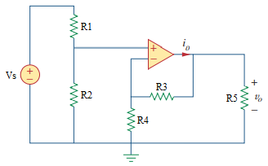

Given *Vs* = 1 V

*R*1 = 10,000 Ω, *R*2 = 90,000 Ω, *R*3 = 100,000 Ω, *R*4 = 50,000 Ω, *R*5 = 10,000 Ω

Find

Variables (สำหรับเขียนโค้ดเพื่อหาคำตอบ)

Random variables

Vs = {1:10};

R1 = {10000:100000:1000};

R2 = {10000:100000:1000};

R3 = {10000:100000:1000};

R4 = {10000:100000:1000};

R5 = {10000:100000:1000};

Global variables

#Vs = 1;

#R1 = 10000; R2 = 90000; R3 = 100000; R4 = 50000; R5 = 10000;

VOUT = R2/R3\*Vs\*(R3+R4)/R4;

Part (กรอกคำตอบ)

1. Vout = VOUT = 2.7 V

5.21 Main Question (สำหรับแสดงข้อสอบ)

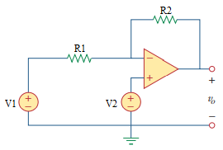

Given *V1* = 3 V, *V2* = 1 V

*R*1 = 4,000 Ω, *R*2 = 10,000 Ω.

Find

Variables (สำหรับเขียนโค้ดเพื่อหาคำตอบ)

Random variables

V1 = {1:10};

V2 = {1:10};

R1 = {1000:10000:1000};

R2 = {1000:10000:1000};

Global variables

#V1 = 3; V2 = 1;

#R1 = 4000; R2 = 10000;

VOUT = (R1\*V2-R2\*V1+R2\*V2)/R1;

Part (กรอกคำตอบ)

1. Vout = VOUT = -4 V

5.25 Main Question (สำหรับแสดงข้อสอบ)

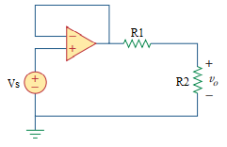

Given *Vs* = 5 V

*R*1 = 12,000 Ω, *R*2 = 20,000 Ω.

Find

Variables (สำหรับเขียนโค้ดเพื่อหาคำตอบ)

Random variables

Vs = {1:10};

R1 = {10000:100000:1000};

R2 = {10000:100000:1000};

Global variables

#VS = 5;

#R1 = 12000; R2 = 20000;

VOUT = R2/(R1+R2)\*VS;

Part (กรอกคำตอบ)

1. Vout = VOUT = 3.125 V

5.38 Main Question (สำหรับแสดงข้อสอบ)

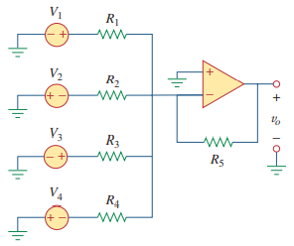

Given *V1* = 1 V, *V2* = 2 V, *V3* = 3 V, *V4* = 4 V

*R*1 = 10,000 Ω, *R*2 = 90,000 Ω, *R*3 = 100,000 Ω, *R*4 = 50,000 Ω, *R*5 = 10,000 Ω.

Find

Variables (สำหรับเขียนโค้ดเพื่อหาคำตอบ)

Random variables

V1 = {1:10};

V2 = {1:10};

V3 = {1:10};

V4 = {1:10};

R1 = {10000:100000:1000};

R2 = {10000:100000:1000};

R3 = {10000:100000:1000};

R4 = {10000:100000:1000};

R5 = {10000:100000:1000};

Global variables

#V1 = 1; V2 = 2; V3 = 3; V4 = 4;

#R1 = 10000; R2 = 90000; R3 = 100000; R4 = 50000; R5 = 10000;

VOUT = -(R5/R1\*V1+R5/R2\*-V2+R5/R3\*V3+R5/R4\*-V4);

Part (กรอกคำตอบ)

1. Vout = VOUT = -0.2778 V

5.47 Main Question (สำหรับแสดงข้อสอบ)

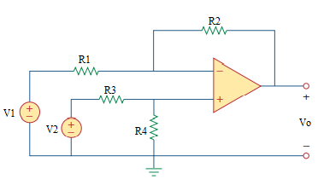

Given *V1* = 1 V, *V2* = 2 V

*R*1 = 2,000 Ω, *R*2 = 30,000 Ω, *R*3 = 2,000 Ω, *R*4 = 20,000 Ω.

Find

Variables (สำหรับเขียนโค้ดเพื่อหาคำตอบ)

Random variables

V1 = {1:10};

V2 = {1:10};

R1 = {1000:100000:1000};

R2 = {1000:100000:1000};

R3 = {1000:100000:1000};

R4 = {1000:100000:1000};

Global variables

#V1 = 1; V2 = 2;

#R1 = 2000; R2 = 30000; R3 = 2000; R4 = 20000;

VOUT = (R2\*(1+R3/R2))/(R3\*(1+R3/R4))\*V2-R2/R1\*V1;

Part (กรอกคำตอบ)

1. Vout = VOUT = 14.09 V